**Exercise 5: Task Management System**

**Singly Linked List:**

Each node points to the next node. One-directional traversal.

**Doubly Linked List**:

Each node has pointers to both the previous and next nodes. Allows bi-directional traversal.

**Output:**

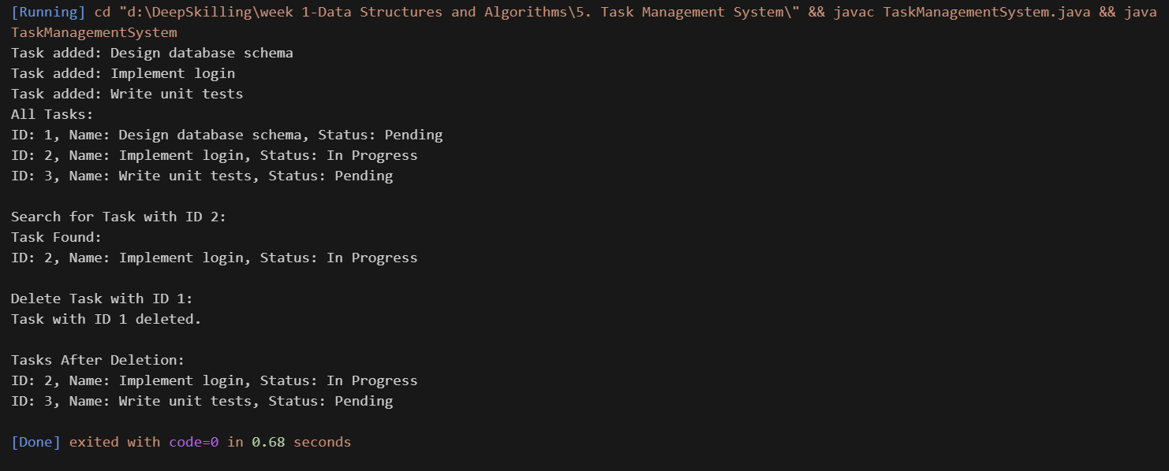

**4. Analysis:**

* **Time Complexity:**

1. Add: O(n)
2. Traverse: O(n)
3. Delete: O(n)
4. Search: O(n)

* **Advantages of Linked list over Array:**
* Dynamic size
* Insert / Delete - Efficient (O(1) at head)